Mid review individual contribution report

# My Contribution

I have created the entire login and registration system, with three different type of users who can be logged in simultaneously. I have two sets of functions which looks after them: 1) register 2) login.

Register function has three capabilities to register, where a user can be registered either as a ‘blood donor’ or ‘patient’ or ‘hospital’. Since the necessity’s changes for each type the form will change accordingly. When the user fills in all the details, he will be sent an OTP to his mail (we haven’t had a static IP for us to send a mail, or else we would send them the mail confirmation link rather sending them the OTP). There in the user is supposed to enter the OTP he was sent to confirm the email. Without email confirmation, he/she is cannot proceed further. I have also created the USER management page where user can change is profile and change his basic settings like password.

The modules I have used for are:

* Social Django.
* Azure Services.
* Microsoft Auth.
* Hash functions.
* PythonCom.
* Pywin32.

# My understanding of the project status (60% done)s

The project status is not as expected. Only some people are working up to mark. Lot many features have to be added to the project. The geolocation thing is not working properly. Blogging part has to be done as soon as possible. Payments may work, but takes some time. Individual portals are done but can be done better. I don’t understand how project can proceed further, if, not all team members are involved?

# My teammates contributions

## Debapriya (team lead)

* He modified models for each app we’ve created.
* He created the organization page where staff can handle the requests incoming by the users.
* Included WHATSAPP API to send messages through WhatsApp to donors, in case of emergency.

## Siddartha

* Does the blogging. Create a chat box where user is supposed to interact with the staff members.

## Sravanthi

* She did the geolocation part where users can retrieve their location. It helps patients find nearest blood banks near them.

## Malavika

* Did the portals for three different types of users.

## suvarat

* Did the inventory control for the staff members.
* Did the payment gateway for the users.

# Ranking

1. Suvarat.
2. Debapriya.
3. Sravanthi.
4. Malavika.
5. Siddhartha.

# Sequence Diagram

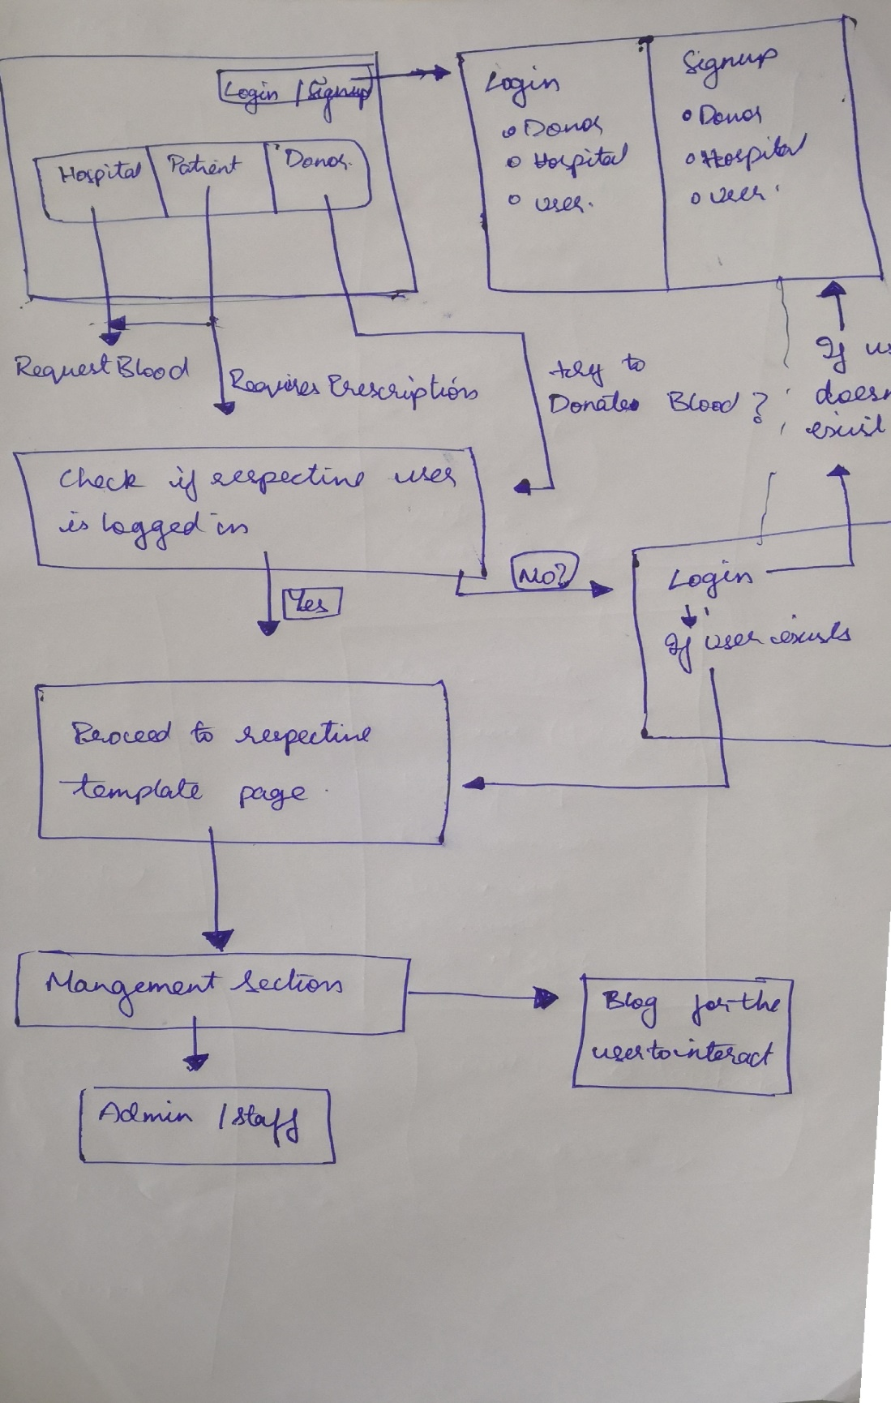

# Class Diagrams

